
Respiratory Care
Training Diploma
King Hussein Cancer Center
Respiratory Therapy Unit
“Join us for bright future and excellent opportunity “

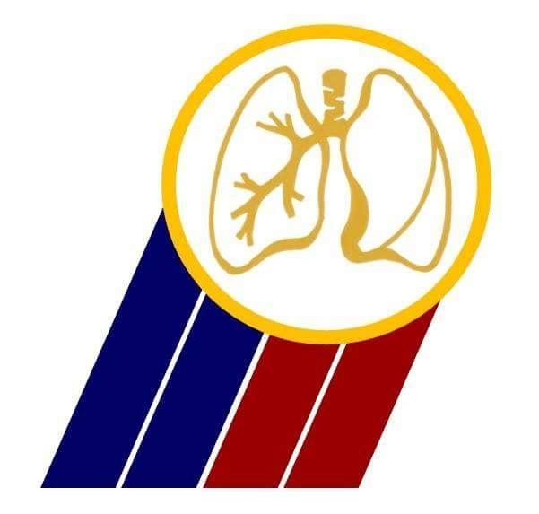

- 1INTRODUCTION:
Course introduces the student to respiratory therapy as a health science profession, including history, professional requirements, responsibilities, professional organizations, and credentialing of the respiratory care practitioner. Provides basic anatomy and physiology, and basic cardiopulmonary pathology in order to give the student a basic foundation for theory and application of Respiratory Therapy.
This course is organized and presented by professional health care providers in an integrated manner for teaching the fundamental and advanced concepts of respiratory care.
This program will help the allied health care professionals who are responsible for caring for patients with deficiencies and abnormalities with cardio-pulmonary system to be able to provide this service based on up to date information and skills
- OBJECTIVE:
At the end of this course, the participant will be able to:
1. Operate and maintain the different types of respiratory equipment's
2. Employ Invasive and Non Invasive mechanical ventilation for patients who need for that service
3. Administer all kind of aerosol medication for all kind of patients
4. Maintain patient’s artificial airway
5. Obtain arterial blood and sputum specimens
6. Perform basic pulmonary function test
7. Participate effectively in CPR team
8. Perform chest physiotherapy

- COURSE OUTLINE:

Course |  | Topics |  | Theory
Life Support course |  | Basic life support |  | 6hr
Anatomy and physiology |  | Anatomy of the Upper and Lower airways, pleura and lungs |  | 10 hr
 |  | Muscles of Respiration
Transportation of gases
Dissociation curves
 |  | Lung volumes and Capacities
 |  | Nervous and chemical control of Respiration. Gas exchange
 |  | Lung mechanics
 |  | anatomy of the heart/ physiology
Respiratory Assessment |  | History |  | 5hr
chest examination
( inspection, palpitation, auscultation)
 |  | General Assessment
 |  | Breath pattern
 |  | cough/sputum
 |  | panel/Trap /sputum culture
MEDICAL gas therapy |  | High flow oxygen therapy |  | 7 hr
 |  | Low flow oxygen therapy
 |  | high flow nasal cannula
 |  | Nitric oxide
 |  | Heliox
Chest physical therapy |  | Lung Expansion Therapy |  | 6hr
 |  | Bronchial hygiene therapy
Diagnostic Techniques |  | Arterial blood gases |  | 15 hr
 |  | Blood test
 |  | Chest X-ray
PFT

Polysomnography
Capnograph

Aerosol Therapy |  | Indication |  | 6hr
 |  | Procedure
 |  | Complication
 |  | Bronchodilator ,antibiotic ,anti-inflammatory, mucolytic
Respiratory Disease |  | C O P D |  | 25hr
 |  | -Asthma
 |  | -Respiratory Distress Syndrome
 |  | -Respiratory failure
 |  | Cystic fibrosis
 |  | interstitial lung disease
 |  | Pneumonia
 |  | pulmonary embolism
 |  | Pulmonary edema
 |  | pleural effusion
 |  | Obstructive sleep apnea
Neuromuscular disease
VAP
Influenza
Trauma
Inhalation burn
Tuberculosis
Postoperative Atelectasis
Pleural disease

Pharmacology |  | Respiratory medication |  | 5hr
 |  | Sedatives and analgesics
 |  | E.cart medication
Equipments in Respiratory Care |  | Oxygen Flow meters |  | 4 hr
 |  | Incentive Spirometers
 |  | Bronchoscope
 |  | Humidifiers
 |  | Artificial airways – Basic & Advanced
 |  | Nebulizer/Inhaler
 |  | Cylinders
Noninvasive ventilation |  | Indication, Contra indication, Modes |  | 4hr
 |  | Monitors, Complication, troubleshooting
Airway Management |  | Tracheostomy |  | 5hr
 |  | Endo tracheal tube management
Mechanical Ventilation |  | Initiation of Mechanical ventilation |  | 37 hr
Modes of mechanical ventilation
wave form
 |  | Monitoring/care of during mechanical ventilation
 |  | Troubleshooting during mechanical ventilation
 |  | Complications during mechanical ventilation
 |  | Weaning during mechanical ventilation/Extubation
 |  | New Modes
 |  | Lung recruitment maneuvers
 |  | p/v tool
 |  | HFOV
 |  | Apnea test
Miscellaneous |  | Definition of Respiratory therapy  smoking cessation |  | 15 hr
 |  | Infection control – Meaning, methods of transmission of diseases.
Bronchoscopy
Home respiratory care
Preceptor-Mentorship: definition, Framework
Ethics
Communication
Nutrition Assessment
Patient Safety
Critical Thinking in Respiratory Care
- CLINICAL PRACTICE:
- Total theoretical hours (150) hours

- Total practice hours
27 days (8 hours/day)

- TARGET AUDIENCE:
Nurses, physiotherapists, biology graduate, chemistry graduate and paramedics.
- DURATION:
Six months
- Course fees:
Per student the fees will be 1000 JD. Transportation and lunch breaks are excluded from the cost.

- TEACHING STRATEGIES:
Teaching learning methods utilized to assist the participants in achieving course objectives include:
- Lectures

- Reflective discussion with question-and-answer (Q&A) periods

- Interactive group work

- Case study
- Bedside supervised practice
- Hands on simulators
- Stations

- EVALUATION METHODS;
- Academic Pre/post test
- Reflective discussion
- Q&A
- Bedside test
- Machines and equipments demonstration
- Trouble shouting
- Case study management

- SUCCESSFUL PROGRAM COMPLETION:
To successfully complete this workshop, the learner should:
- Attend all academic lectures of the program
- Participate in individual and group activities, and contribute to the reflective discussions
- Attend all programmed practice hours
- Pass post- test with 70% minimum

- TEACHING STAFF:
- Main speakers:
1-Dr. Firas Hawari, Chief, Section of Pulmonary & Critical Care/Director Respiratory Therapy Service
2-Mr. Iyad Ghonimat Manager, Respiratory Services &PFT lab
3-Asma Tbakhi, Senior Respiratory Therapist
4-Flsteen Aqel, Respiratory Therapist
5-Majdi Olyan, Respiratory Therapist
6-Mohammad Qawasemeh, Respiratory Therapist
7- Heba Khamash, Respiratory Therapist

